

Cornerstone
Project Report
CISC3003 — Web Programming
University of Macau, Faculty of Science and Technology
Team 02 | April 2026
Yiming Luo DC229226 | Jieding Zhang DC228922 | Yujie Yang DC229823
Siyi Chen DC228141 | Zhexuan Zhang DC229576 | Hao Yang DC229340

Table of Contents
Right-click the TOC and select "Update Field" to refresh page numbers.
Table of Contents 2
Project Abstract 4
Project Context 4
Project Goals 5
Project Services and Data Requirements 5
Back-End Services 5
Data Requirements 5
External API Dependencies 5
Project Tasks and Tools 5
1. Topic Clarification and Audience Definition 5
2. Research and Reference Collection 6
3. Content Planning and Site Structure Design 6
4. Website Development 6
5. Responsive Design and Usability Improvement 6
6. Accessibility and Content Review 6
7. Final Revision and Presentation 6
Project Challenges 7
Project Deliverables 7
Division of Work 7
Project Evaluation 8
Project Learning 9
Project Test Cases for Functional Requirements 9
TC-001: User Registration 9
TC-002: Registration Validation — Empty Fields 9
TC-003: Registration Validation — Password Mismatch 9
TC-004: User Login 10
TC-005: Login Validation — Invalid Credentials 10
TC-006: Authentication Gate — AI Chat 10
TC-007: AI Chat — Authenticated Access 10
TC-008: Theme Toggle 10
TC-009: Responsive Navigation 11
TC-010: Page Navigation — All Links 11
Demo Walkthrough 11
1. Home Page 11
2. Registration Page 12
3. Login Page 12
4. Skills Development Page 13
5. AI Chat Page (Authenticated) 13
6. AI Chat Page (Unauthenticated) 14
7. Job Readiness Page 14
8. Daytime Mode Theme 15
Citations and References 15
Declaration of AI Usage 15

Project Abstract
This project presents Cornerstone, a full-stack web application designed as an academic and career development handbook for computer science undergraduate students at the University of Macau. Developed using Node.js, Express, SQLite, and vanilla HTML/CSS/JavaScript, the platform delivers structured guidance across seven chapters: About, Skills, Master's, Careers, Jobs, Readiness, and Reflection.
The application features responsive web design (RWD), a dark/light mode toggle, user authentication with registration and login, a personalized "My List" bookmarking system, and an AI-powered chat interface for interactive academic advising. Deployed on Render at https://cornerstone-lpu4.onrender.com, the system demonstrates practical integration of front-end presentation, back-end API services, database persistence, and third-party AI integration.
This report documents the project context, goals, technical architecture, division of work, implementation challenges, testing outcomes, and reflections on team learning throughout the development lifecycle.

Project Context
Cornerstone is a full-stack web application built for the CISC3003 Web Programming course at the University of Macau. The project was developed by Team 02 and deployed to Render, accessible at https://cornerstone-lpu4.onrender.com.
The application follows a client-server architecture. The front-end is built with semantic HTML5, CSS3 with custom properties for theming, and vanilla JavaScript for DOM manipulation and API consumption. The back-end is powered by Node.js and Express.js, handling RESTful API routes, session-based authentication, and middleware for request validation. Data persistence is managed through SQLite, storing user accounts, saved programme and job entries, and chat history.
The application implements Responsive Web Design (RWD) principles using CSS Flexbox and Grid layouts, media queries for breakpoints at 768px and 1024px, and fluid typography to ensure usability across mobile, tablet, and desktop viewports. Additional features include a theme toggle using CSS custom properties and localStorage persistence, and a mobile-responsive navigation menu.

Project Goals
The primary goal of this project is to design and develop a website that supports computer science students in understanding academic growth and future career development. Many students in computing know that they need to build technical skills and prepare for the future, but they often lack a clear way to organize information about self-learning, graduate study preparation, and different job paths.
The website presents this information in a structured, readable, and accessible way through clear navigation, visual hierarchy, responsive layout, and user-centered content organization. It is designed not only as a course project grounded in shared academic experience, but also as a practical information platform for CS undergraduates.
The project supports the learning outcomes of Web Programming by requiring the team to plan a complete website, structure content clearly, apply appropriate HTML and CSS, and use JavaScript to improve interaction and user experience. It also develops the ability to present technical and academic information in an organized digital form.

Project Services and Data Requirements

Back-End Services

Data Requirements
The SQLite database stores three primary data entities: user accounts (id, display_name, email, password_hash, created_at), saved items (id, user_id, item_type, item_data, created_at), and chat history (id, user_id, role, content, timestamp). Session tokens are managed in server memory.

External API Dependencies

Project Tasks and Tools

1. Topic Clarification and Audience Definition
We confirmed the scope of the website and defined the main audience as computer science students who want to understand how to prepare for academic development and future employment. The main content areas include skills development, self-learning, master's preparation, career pathways, and job readiness.

2. Research and Reference Collection
We studied examples of educational and career-related websites to understand how they organize information and guide users. We also reviewed web design principles related to responsiveness, accessibility, and usability so that the site is informative and easy to use.

3. Content Planning and Site Structure Design
We planned the main sections of the website and decided how users would move through the content. The website includes sections such as Home, About, Skills Development, Master's Preparation, Career Paths, Job Readiness, and Reflection. We prepared a sitemap and wireframe to ensure the structure is logical and easy to follow.

4. Website Development
We built the website using HTML, CSS, and JavaScript. HTML defines the structure and content, CSS controls layout and visual style, and JavaScript supports navigation and interaction. The work was divided between team members focusing on front-end structure, content integration, back-end API development, and AI integration.

5. Responsive Design and Usability Improvement
We tested the layout on different screen sizes and adjusted spacing, text arrangement, image placement, and navigation as necessary. We also reviewed whether the site is easy to read and whether users can quickly understand the purpose of each section.

6. Accessibility and Content Review
We reviewed the website to ensure it uses clear headings, meaningful page structure, readable text, appropriate link text, and alternative text for images. We followed accessibility guidance emphasizing the importance of structure, plain language, and semantic markup.

7. Final Revision and Presentation
In the final stage, we refined the site visually and technically, made corrections where needed, and prepared the final version for submission. We collected screenshots and final visuals to show the completed website and explain how it meets the project goals.

Project Challenges
Throughout the development of Cornerstone, our team encountered several technical and collaborative challenges:
1. Front-End and Back-End Integration: Coordinating API contracts between the vanilla JavaScript front-end and the Express back-end required careful planning. We addressed this by documenting endpoint specifications before implementation and using consistent JSON structures.
2. AI Chat Integration: Integrating the Moonshot AI API while maintaining conversation context and handling API rate limits posed challenges. We implemented a loading state indicator, error handling for failed requests, and a fallback message when the service is unavailable.
3. Responsive Design Complexity: Ensuring consistent visual presentation across the seven content-heavy pages on mobile, tablet, and desktop required extensive CSS testing. The theme toggle (light/dark mode) added complexity to the color management system.
4. Team Coordination: With six team members working on different components (front-end pages, back-end API, database, AI integration, testing), maintaining code consistency and avoiding merge conflicts required disciplined Git workflow practices and regular stand-up meetings.

Project Deliverables

Division of Work
Pair 1: Frontend Development (Luo Yiming, Yang Hao)
Luo Yiming and Yang Hao were responsible for the overall UI/UX design of the website. They independently developed 16 HTML pages with fully responsive layouts to ensure optimal presentation across mobile, tablet, and desktop devices. In addition, they implemented a dual dark/light theme toggle and handled all client-side interaction logic, including page navigation, dynamic visual feedback, and form validation, thereby delivering a smooth, consistent, and visually polished browsing experience.
Pair 2: Data, AI & DevOps (Zhang Zhexuan, Chen Siyi)
Zhang Zhexuan and Chen Siyi focused on data infrastructure, AI integration, and deployment operations. They collected and structured the necessary data resources covering academic programmes and career opportunities. For the AI component, they built the chatbot backend by integrating the DashScope API to enable natural language understanding and response capabilities. Furthermore, they managed server environment configuration and production deployment, ensuring the system remained accessible and stable in live environments.
Pair 3: Backend Architecture & Quality Assurance (Yang Yujie, Zhang Jieding, Jiao Zinan)
Yang Yujie, Zhang Jieding, and Jiao Zinan jointly handled the core backend architecture and quality assurance. They designed and implemented the user authentication system, RESTful API routes, and database schema to provide secure and reliable data support for frontend functionalities. Beyond development, this group led comprehensive testing efforts, including unit and integration tests, while continuously debugging, handling exceptions, and optimizing performance throughout the development cycle to guarantee the system's stability and usability met project standards.

Project Evaluation
The project evaluation was conducted against the success criteria defined in the original proposal and the functional requirements of a full-stack web application.
The website has a clear and meaningful purpose. Users can quickly understand that the site is designed to support computer science students in areas such as skills development, graduate preparation, and career exploration. The content is well organized into seven chapters with logical navigation, allowing users to move through the site easily.
The design is consistent and readable. Fonts, colors, spacing, and layout work together to create a clean and professional appearance. The CSS custom properties system enables unified theming across all pages, including the light/dark mode toggle.
The website is fully responsive. The layout remains usable and readable on different screen sizes through Flexbox and Grid layouts, media queries at 768px and 1024px breakpoints, and fluid typography. The site has been tested on desktop, tablet, and mobile viewports.
The full-stack functionality is complete. The Node.js/Express back-end handles RESTful API routes, the SQLite database manages user accounts and saved items, and the AI chat integration provides interactive career and academic guidance. User authentication with registration, login, and session management is fully implemented.
Overall, the project exceeded the original proposal's scope by evolving from a planned static website into a complete full-stack application with authentication, database persistence, AI integration, and responsive design. All core features function as intended, and the deployed application is stable and publicly accessible.

Project Learning
Throughout this project, the team gained practical experience in full-stack web development. We learned how to integrate front-end presentation layers with back-end services and database operations, design API contracts, handle asynchronous requests, and manage data flow between client and server.
Working with six contributors taught us the importance of branch management, pull request reviews, and resolving merge conflicts. We adopted a feature-branch workflow that reduced integration issues.
We also learned to manage project scope as the project evolved from a static site to a full-stack application. Prioritizing features and delivering a functional MVP before adding enhancements helped us complete the project on time. Configuring the Render deployment pipeline provided hands-on experience with modern deployment practices.

Project Test Cases for Functional Requirements

TC-001: User Registration
Steps: Navigate to signup page. Enter valid display name, email, password (at least 8 characters), and confirm password. Click "Create account".
Expected Result: Account is created, user is redirected to home page.
Status: Pass

TC-002: Registration Validation — Empty Fields
Steps: Navigate to signup page. Leave all fields empty. Click "Create account".
Expected Result: Form displays validation error for required fields.
Status: Pass

TC-003: Registration Validation — Password Mismatch
Steps: Enter matching passwords except in the confirmation field. Click "Create account".
Expected Result: Error message indicates passwords do not match.
Status: Pass

TC-004: User Login
Steps: Navigate to login page. Enter registered email and password. Click "Sign in".
Expected Result: User is authenticated, session is established, and user is redirected to the previous page or home.
Status: Pass

TC-005: Login Validation — Invalid Credentials
Steps: Enter unregistered email or wrong password. Click "Sign in".
Expected Result: Error message indicates invalid email or password.
Status: Pass

TC-006: Authentication Gate — AI Chat
Steps: Ensure not logged in. Navigate to /chat.html.
Expected Result: Page displays "Sign in to use ChatBox" with sign-in button. Chat interface is hidden.
Status: Pass

TC-007: AI Chat — Authenticated Access
Steps: Log in with valid credentials. Navigate to /chat.html. Type a question about CS career advice and send.
Expected Result: AI responds with relevant career advice. Response is displayed in chat window.
Status: Pass

TC-008: Theme Toggle
Steps: Click the theme toggle button on any page. Observe color scheme. Refresh the page.
Expected Result: Color scheme switches between light and dark. Preference persists after refresh via localStorage.
Status: Pass

TC-009: Responsive Navigation
Steps: Open website on desktop (width above 1024px). Resize to tablet (768px-1024px). Resize to mobile (below 768px).
Expected Result: Desktop shows full horizontal nav; tablet shows condensed layout; mobile shows stacked navigation.
Status: Pass

TC-010: Page Navigation — All Links
Steps: From home page, click each navigation link (About, Skills, Master's, Careers, Jobs, Readiness, Reflection, AI Chat). Click site logo to return home.
Expected Result: All links navigate to correct pages. Logo returns to home page.
Status: Pass

Demo Walkthrough
The following screenshots demonstrate the key features and pages of the Cornerstone application.

1. Home Page
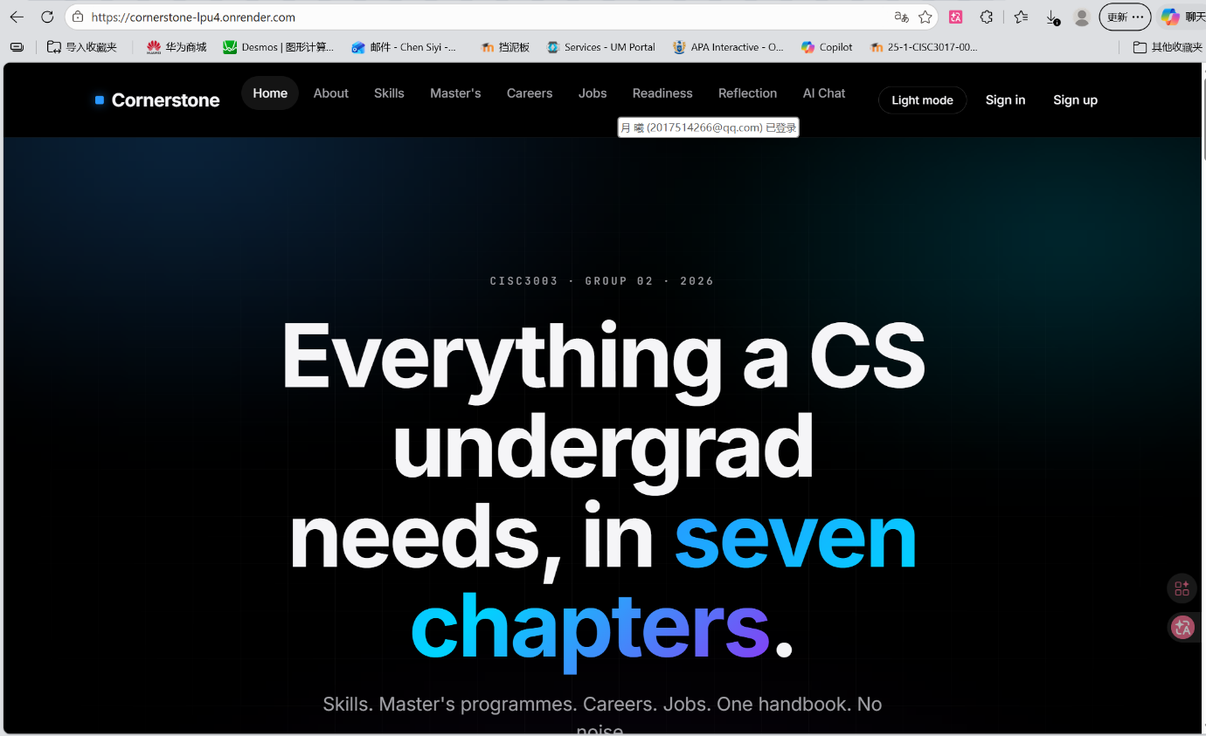
The landing page establishes the site's purpose and provides entry points to all seven chapters and account creation.

2. Registration Page
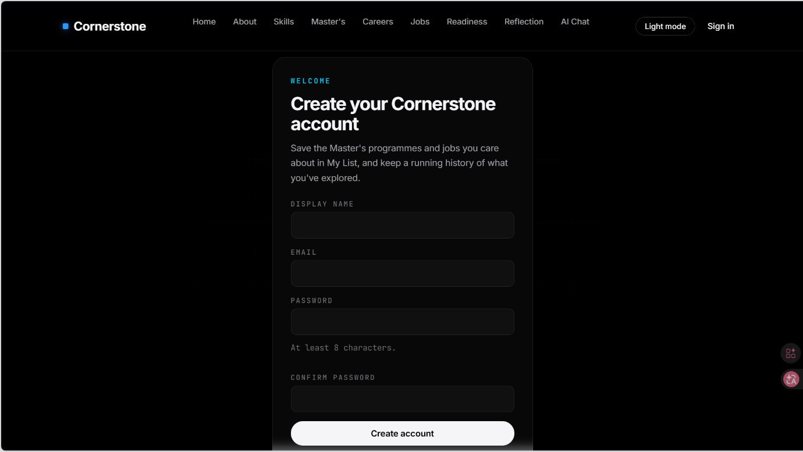
The registration page implements client-side and server-side validation for all fields.

3. Login Page
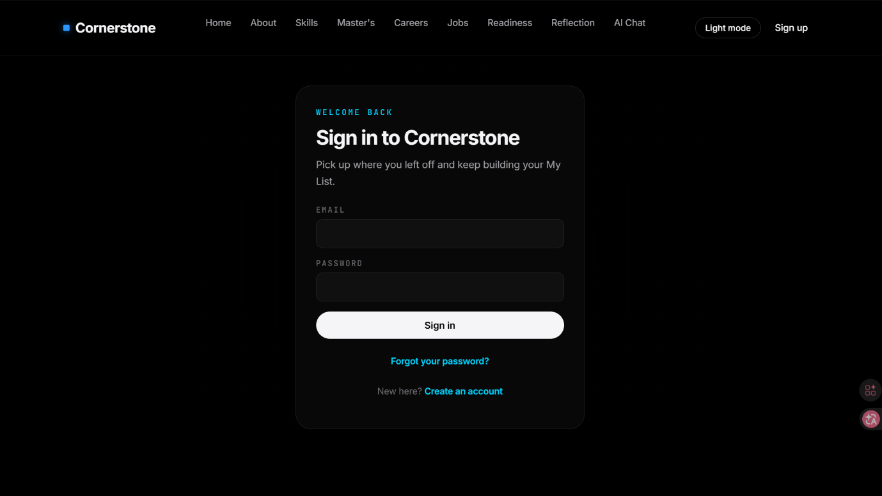
The login system establishes a session and redirects authenticated users to their intended destination.

4. Skills Development Page
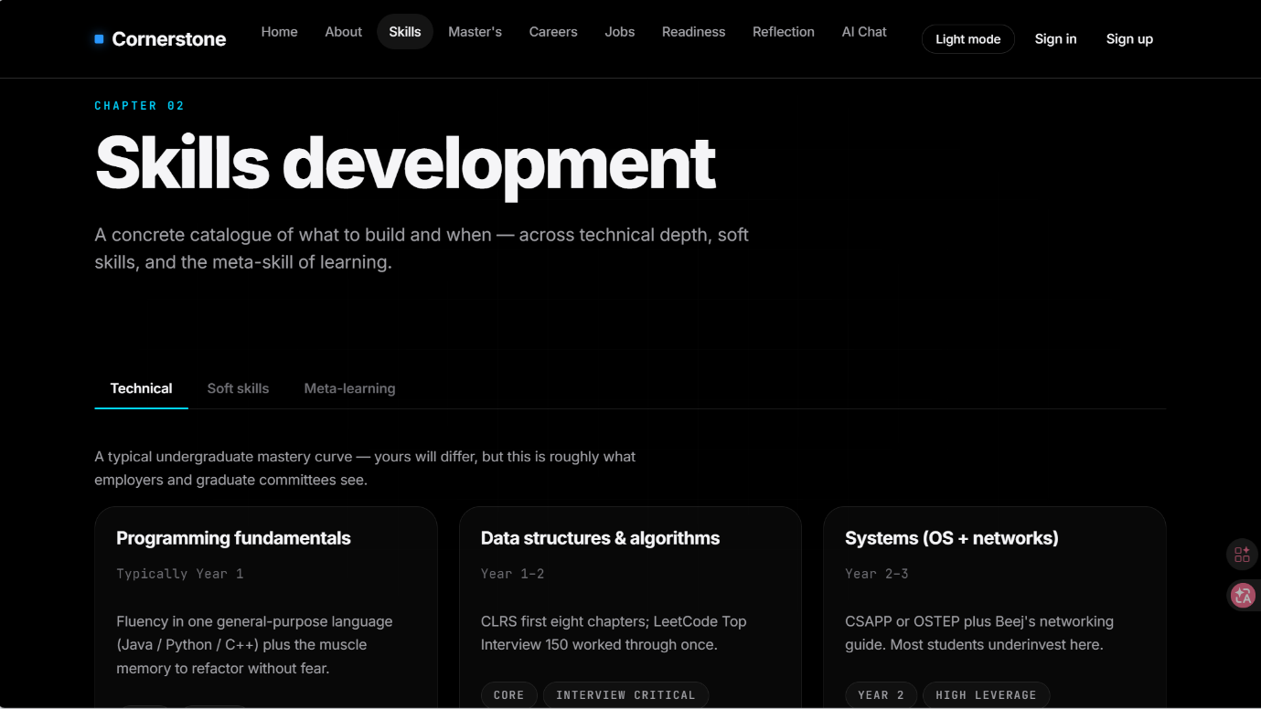
This page uses collapsible details/summary elements and CSS-styled progress bars to visualize skill development paths.

5. AI Chat Page (Authenticated)
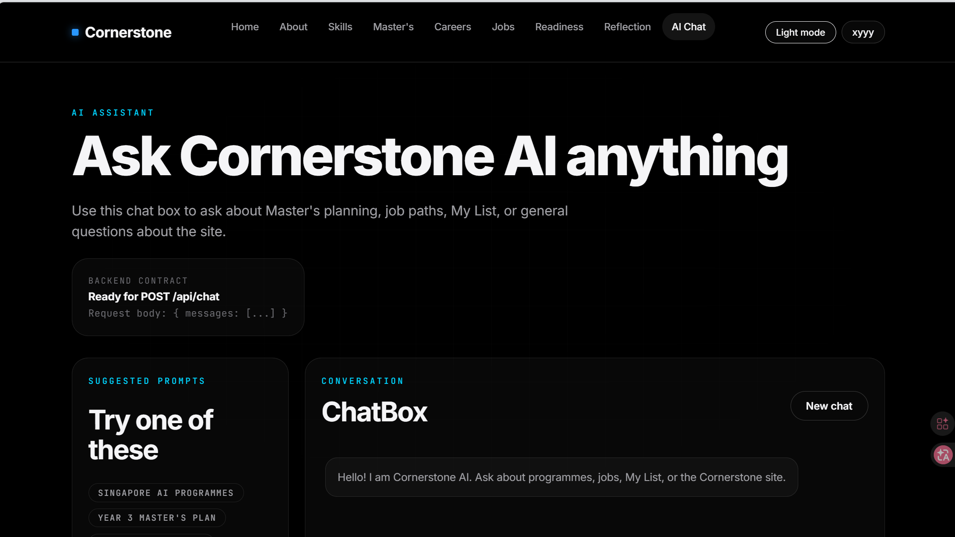
The AI Chat integrates with the Moonshot AI API to provide interactive academic and career guidance.

6. AI Chat Page (Unauthenticated)
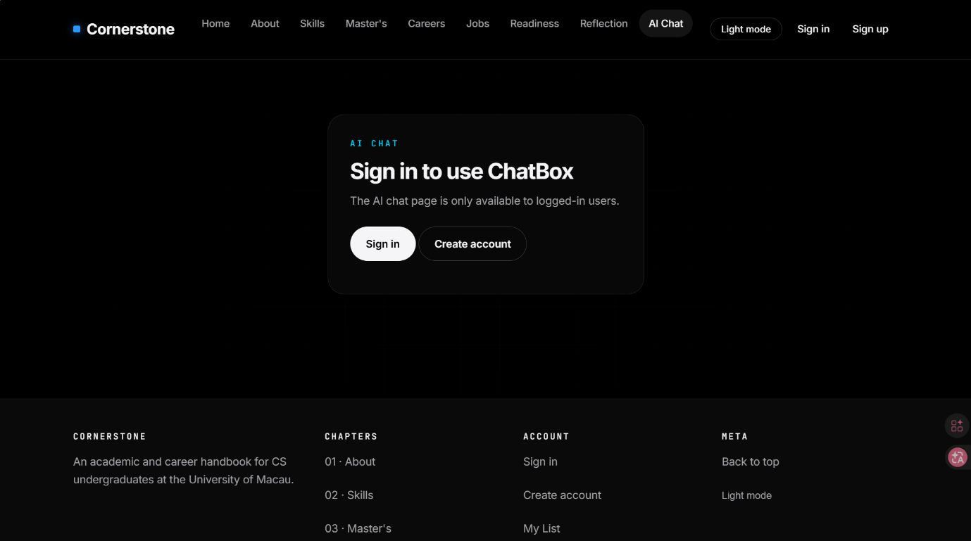
The authentication gate ensures only logged-in users can access the AI chat feature.

7. Job Readiness Page
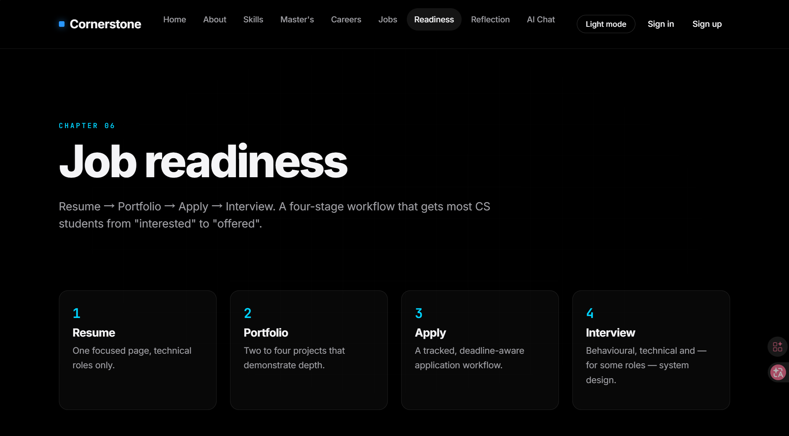
This chapter provides a structured guide to job application preparation.

8. Daytime Mode Theme
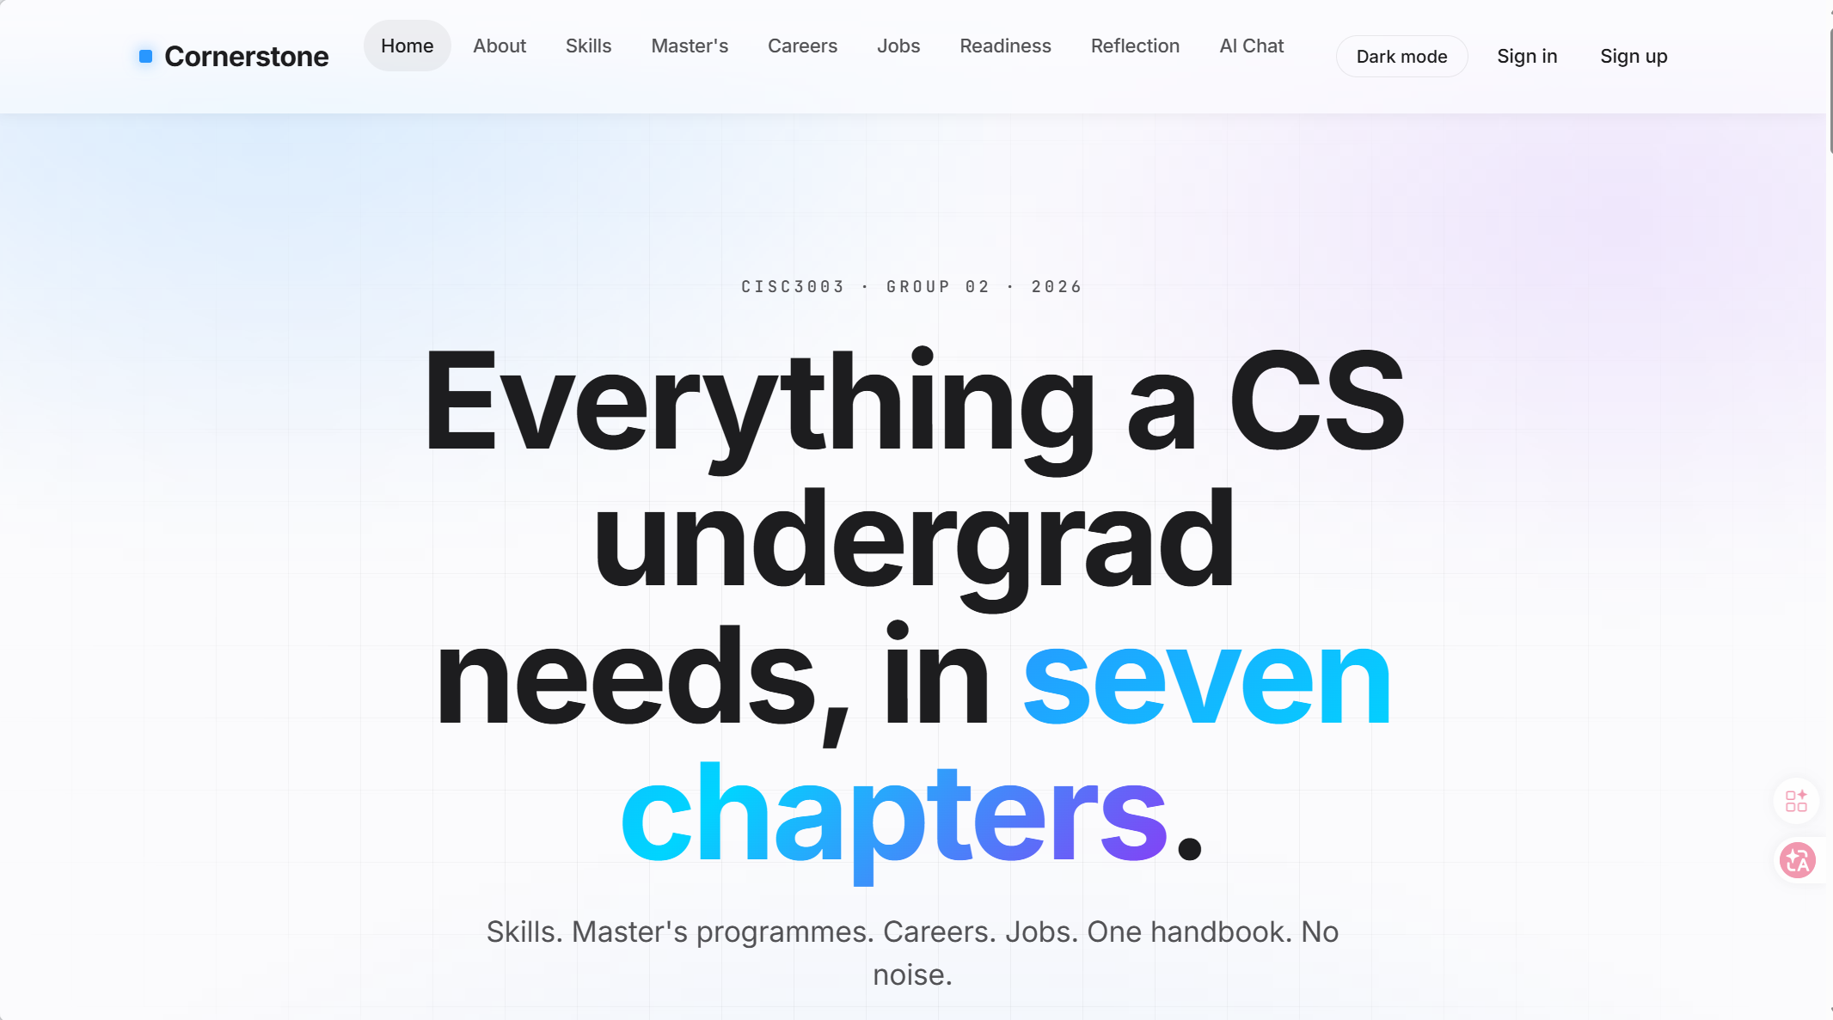
The theme toggle uses CSS custom properties and persists user preference in localStorage.

Citations and References
Mozilla. (2025a, November 4). HTML: A good basis for accessibility. MDN Web Docs. https://developer.mozilla.org/en-US/docs/Learn_web_development/Core/Accessibility/HTML
Mozilla. (2025b, December 19). Responsive web design. MDN Web Docs. https://developer.mozilla.org/en-US/docs/Learn_web_development/Core/CSS_layout/Responsive_Design
Nielsen Norman Group. (2017, October 1). First impressions matter: How designers can support users' automatic thinking. https://www.nngroup.com/articles/first-impressions-human-automaticity/
World Wide Web Consortium. (n.d.). Introduction to web accessibility. W3C Web Accessibility Initiative. https://www.w3.org/WAI/fundamentals/accessibility-intro/
World Wide Web Consortium. (2025, May 6). Web Content Accessibility Guidelines (WCAG) 2.1. https://www.w3.org/TR/WCAG21/

Declaration of AI Usage
In the development of the Cornerstone project, artificial intelligence tools were used in the following circumstances and for the following purposes:
1. Web Design Refinement: We used AI to optimize the visual style and layout of the website, settling on a dark theme, card-based design, and chapter-based navigation. AI-assisted suggestions helped refine the color palette, spacing system, and overall visual hierarchy across the seven content chapters.
2. Content Distillation: We leveraged AI to condense large amounts of raw data (e.g., Master's programmes, job openings) into concise cards and one-line summaries for better readability. This allowed us to present dense academic and career information in a format that is accessible and scannable for undergraduate users.
3. AI Chat Feature: We integrated an external API (Moonshot AI) to add an AI Chat entry point for basic Q&A on career and school selection. This feature provides users with interactive guidance on academic planning and career decisions, complementing the static content of the handbook.
We acknowledge that AI tools were used as assistive resources during the development process. All team members reviewed and validated AI-generated outputs before incorporation into the project. The core architecture, design decisions, code logic, and content accuracy remain the responsibility of Team 02.


Cornerstone
A CS Academic & Career Handbook
University of Macau | CISC3003 | 2026

